**IoT Based Vehicle Tracking Using NodeMCU 4G/5G Connectivity**

Malhar S. Jojare   
*Student, School of Electronics and Communication,*  
*MIT World Peace University,*Pune, India  
 malharjojare0664@gmail.com

Ashutosh U.Solanke  
*Student, School of Electronics and Communication,*  
*MIT World Peace University,*Pune, India  
 ashusolanke007@gmail.com

Hrushikesh A.Kalamkar  
*Student, School of Electronics and Communication,*  
*MIT World Peace University,*Pune, India  
 hrushlip18@gmail.com.com

***Abstract*— In this paper, we study the design and different methodology of automated intelligent vehicle (AIV) systems. This paper provides an overview on use of LIDAR technology in AIV system and discusses recent technological developments in Autonomous transportation.The approach is tested for a known database, as well as for real-life scenarios.For precise localization, a sensor for AIV application must measure these targets over a long range. In addition, in many scenarios, an AIV moves in the daytime and at night, both indoors and outdoors. Therefore, a sensor for AGV application must have the capability of target distance measurement under many lighting conditions. To this end, LIght Detection and Ranging (LIDAR) yields particularly useful sensors in various scenarios. In addition, these sensor outputs are helpful for precise localization.**

***Keywords— IoT, Smart Vehicle Tracking, SIM7600, NodeMCU***

# **Introduction**

Autonomous Intelligent vehicle is the future smart cars anticipated to be driver less, efficient and crash avoiding. To reach this goal automakers have started working in this area to realize the potential and solve the challenges currently in this area to reach the expected outcome. In this regard the first challenge would be to customize and imbibe existing technology in conventional vehicle to translate them to a near expected autonomous car. This transition of conventional vehicles into an autonomous vehicle by adopting and implementing different upcoming technologies is discussed in this paper. This includes the objectives of autonomous vehicles and their implementation.Various semi-autonomous features introduced in modern cars such as lane keeping, automatic braking and adaptive cruise control are based on such systems. Extensive network guided systems in conjunction with vision guided features is the future of autonomous vehicles. It is predicted that most companies will launch fully autonomous vehicles by the advent of next decade. The future of autonomous vehicles is an ambitious era of safe and comfortable transportation.

# Literature Review

The aim of the literature survey is to distinguish between the existing projects and published products with their several approaches and methodologies that has been done in the field of IoT based Smart Vehicle tracking.

Smart vehicle tracking using the GLONASS an emerging radio-based satellite navigation system was introduced in [1]. This proposed system allows organizations to track their vehicles and to get exact location of vehicle. The system allows those companies to monitor the travelled routes through a web client that uses the Google Maps API and shows colors on the map to indicate if the devices on route. The general evaluation result is that the system proved to be reliable as to view the positioning of the devices.

A novel method for assessing the quality of vehicle tracking system using IoT is presented in [2]. Vehicle tracking system is very essential in major cities and nowadays vehicle accidents are rapidly increasing, hence the module consisting of temperature, alcohol and eye blink sensor is developed for tracking the vehicle, vehicle temperature, alcohol consumption of driver, sleepiness, or drowsiness. This work survey has improved the Quality of service and security.

In [4], vehicle monitoring and controlling system: sensor-actuator module and communication module used monitor and control the vehicle. Using GPS module’s NMEA string format. An effective solution is provided to develop the intelligent system for vehicles which will monitor alcohol consumption concentration of the driver of the vehicle and will send this data to the base unit as explained in this paper, by using hardware platform consisting of Alcohol sensor MQ3, micro-controller, Li-Fi system, GSM module, ECU of car. The designed system in [8] would finish the function of communicating with the base station via Li-Fi, GSM and control of various parameters. The whole Control system has the advantage of small volume and high reliability.

# **Electronic Components**

1. RASPBERRY PI 3B+

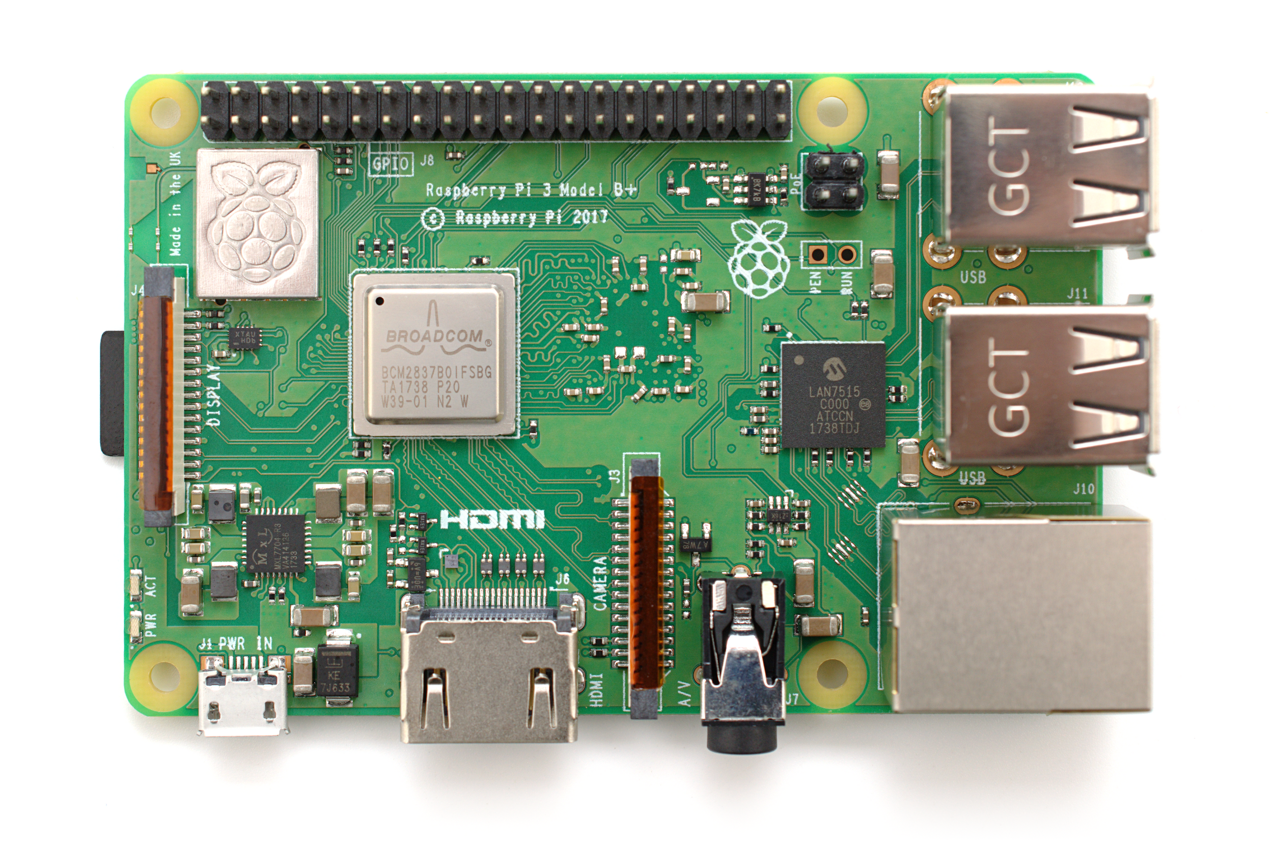

Raspberry Pi 3B+ is a powerful microprocessor that runs a Raspian operating system on it. Rapspian operating system

The GPS tracking device market is segmented based on type, application, and geography.

1. By Type
   1. Data loggers
   2. Data pushers
   3. Data pullers
   4. Covert GPS Trackers
2. By Application
   1. Aerospace & Defense
   2. Oil & Gas
   3. Mining
   4. Transportation
   5. Others

# Implementation Setup

1. Components Required-
   1. ESP8266

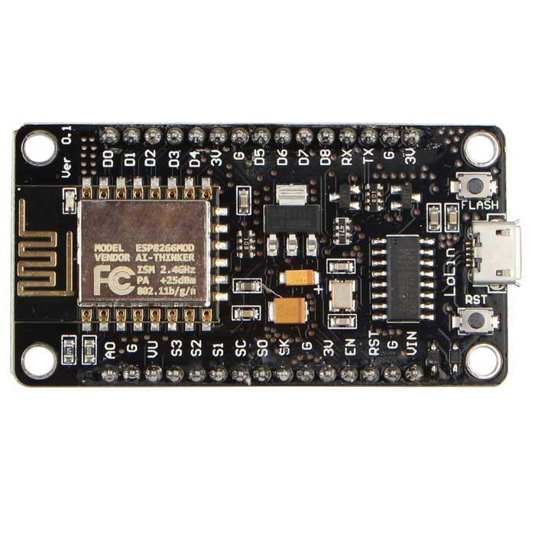

The primarily known as NodeMCU, the development board with built-in WiFi and similar programming module as of ATmega32 is a perfect for many IoT applications, the advantages of the controller board are low-cost compared to similar boards present in market, the open source 32-bit MCU firmware for development, built in TCP/IP stack and support for MQTT protocols.

* 1. SIM7600 4G/5G HAT

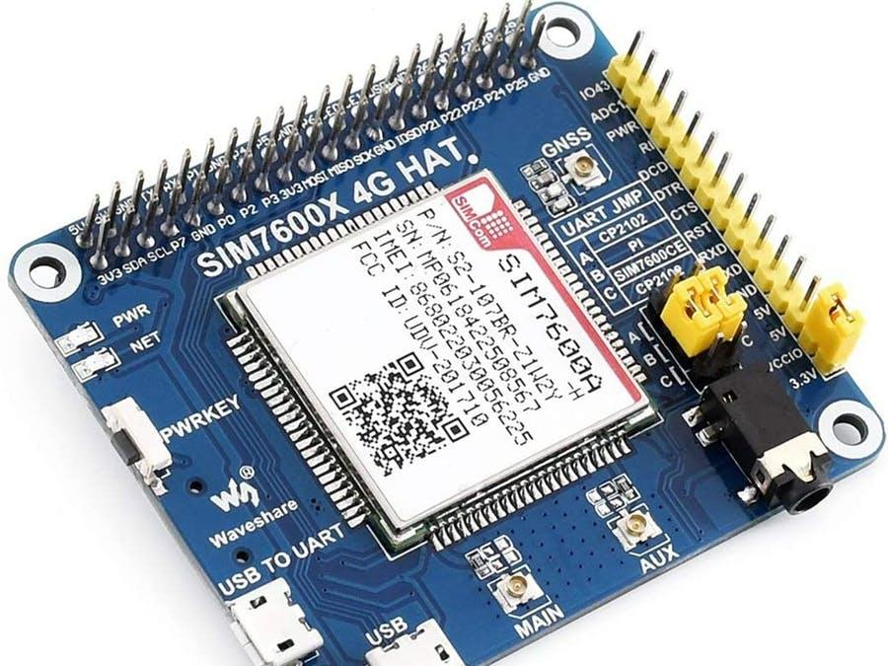

The SIM7600 4G/5G HAT primarily known as a 4G/5G GSM module which provides support to modern development boards such as Arduino, ESP8266, Raspberry Pi, Jetson Nano etc., it provides support LTE CAT4 up to 150 mbps downlink data transfer. As represented here, the HAT consists of RPI connector head and 15 pin control interfaces with main, aux and GNSS antenna support. The board supports dial-up, telephone calls, SMS, mail, TCP, UDP, DTMF, HTTP, FTP etc. protocols to transfer the information, the micro-USB port is given to test the AT commands on the board using laptop/desktop with on-board audio jack. The process of testing the board with desktop/laptop follows as,

### Insert the SIM card and earphone to the ports

### Connect the USB interface to PC

### After connecting power led will start

### Long press power button on the board the network led will start blinking(if not check SIM card is mount properly)

| **Network LED status** | **Module status** |
| --- | --- |
| Always ON | Searching Network |
| 200ms ON/OFF cycle | SIM registered; Data transmit at 4G |
| 800ms ON/OFF cycle | SIM registered; Data transmit at 2G/3G |
| Always OFF | Power OFF; Sleep |

### Open device manager on PC, enable hidden contents from view menu

### Navigate to unrecognized ports

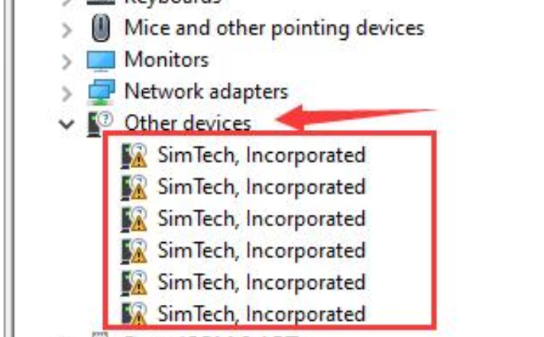

### Click on one of the port and update [driver](https://www.waveshare.com/wiki/File:SIM7X00-Driver.7z) manually

### After updating download one of the serial debugger

### Here we have used [DF Serial Debugger](https://wiki.dfrobot.com/GPS_GPRS_GSM_Module_V3.0__SKU_TEL0051_)

### Test AT commands after that

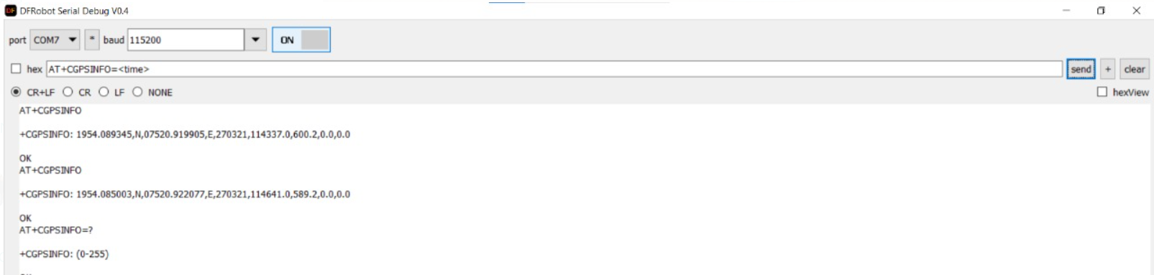

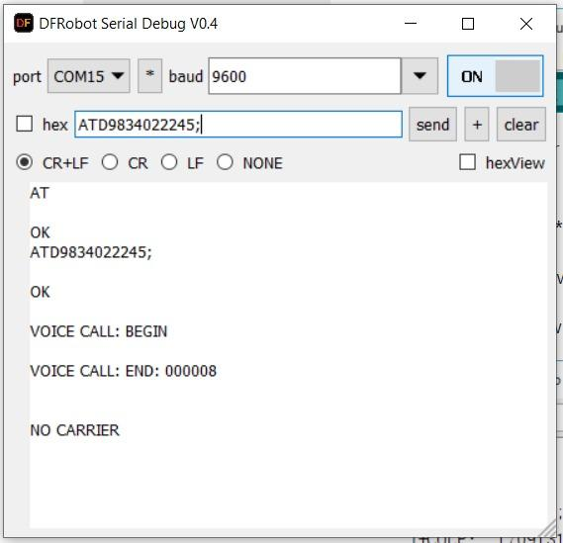

* 1. Buttons

1. Block Diagram-

The block diagram designed here includes internal structure of SIM7600 connections with ESP8266 as main controller board, and an emergency button if user needed any help from emergency contacts. The SIM7600 internal blocks contains processor, RF transceiver and power management as main blocks of the modules. The hardware interfaces provide by the module via Mini PCI Express Card connector are Power supply, PCM, WAKE#, I2C, USB, USIM, W_DISABLE, LED_WWAN#, Analog Audio response, UART, PERST#. The function overview of the blocks is, there are 3 blocks for receiving and transmitting the data which are GSM/UMTS/LTE of Main Ant which connects to the mobile network to access the internet and make/receive calls, UMTS/LTE RF FEM of AUX Ant it is also known as diversity antenna, it is used for error correction its effects are visible in poor signal strength areas and lastly the GNSS RF of GNSS Ant which used for receiving significant position in latitude and longitude. The PRX and DRX means continuous and discontinuous reception to RF transceiver. The RF transceiver is connected processor to handle the data, using hardware interfaces provided by module one can access the data via 52 Pin MINI PCI-E interface and 15 Pins of these are of Control interface which is used to connect to the controller board.

The ESP8266 Rx, Tx, Vcc and GND is connected to 15 Pin control interfaces of module to access the data and a power bank is provided for continuous power supply, the one can attached or detached the power bank for system turn ON/OFF.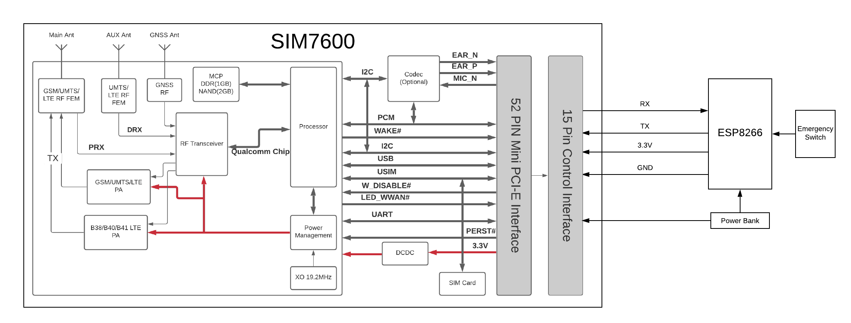

# Working of the Setup

The aim of the literature survey is to distinguish between the existing projects and published products with their several approaches and methodologies that has been done in the field of IoT based Smart Vehicle tracking.

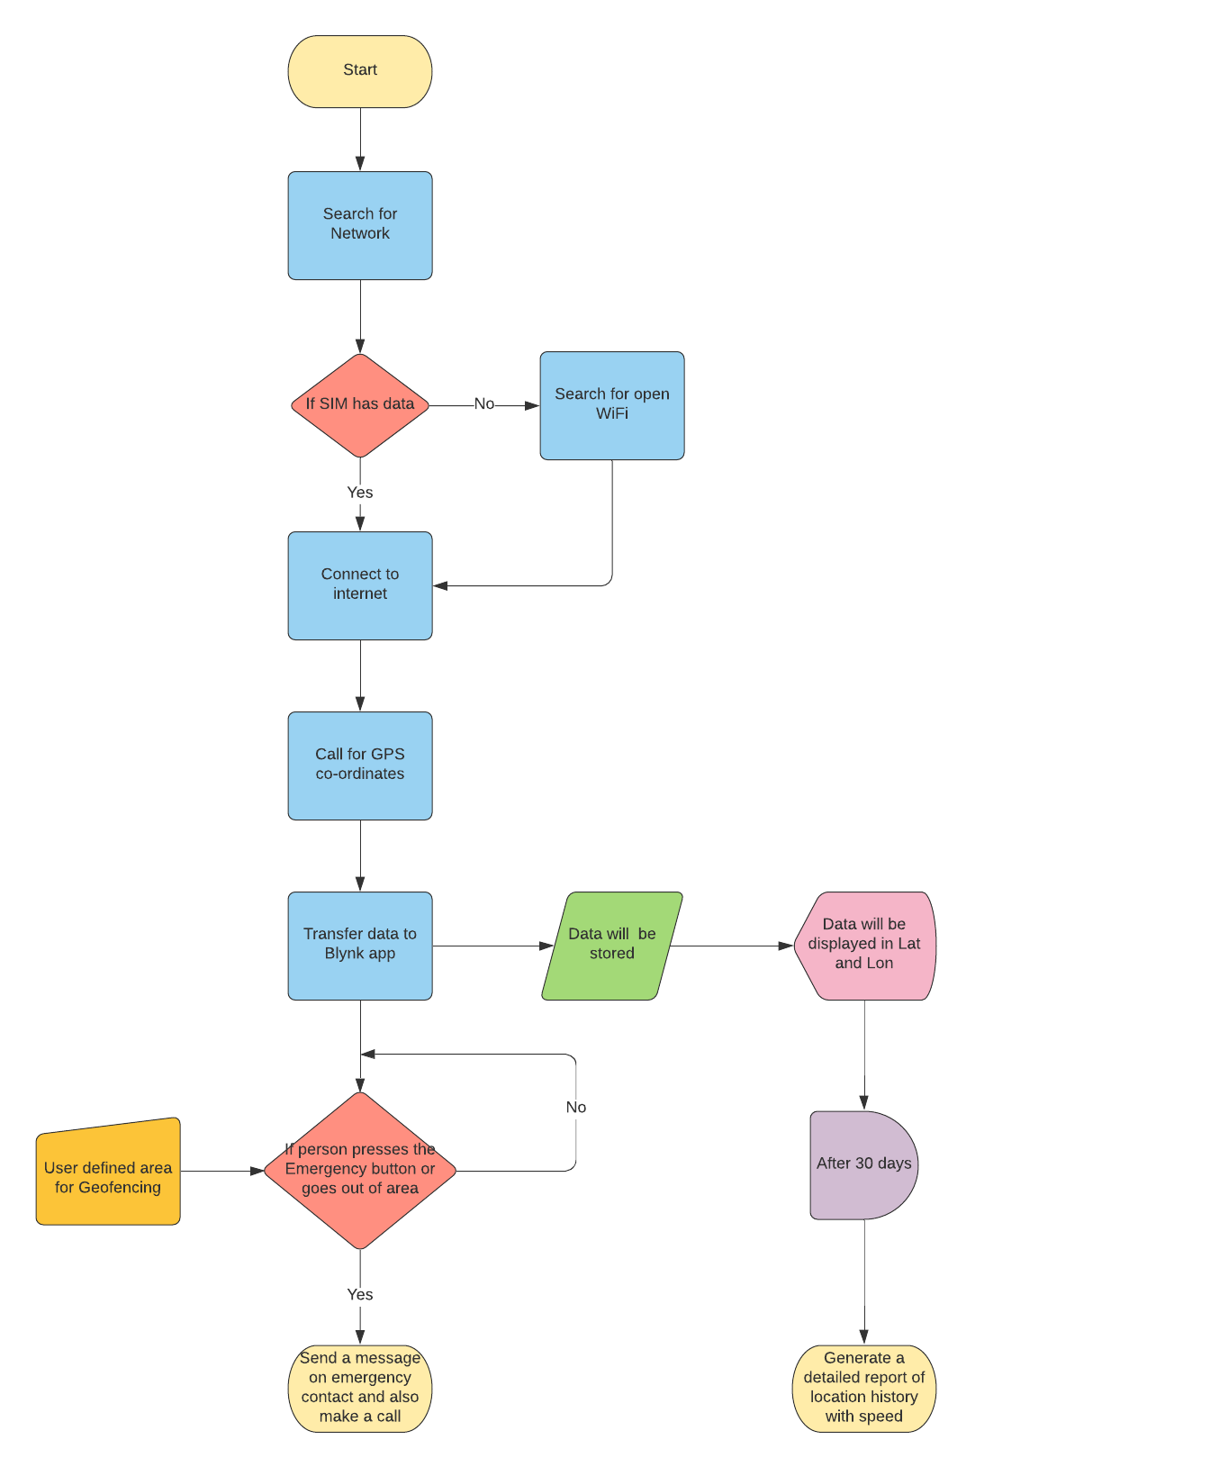

# Product Comparison

| Specs/ Provider | Loco-Nav | Trans-poco | Tracking Genie | Auto  Wiz | Our Product |
| --- | --- | --- | --- | --- | --- |
| Real-time Tracking | Yes | Yes | Yes | Yes |  |
| Ignition Status | Yes | No | Yes | Yes |  |
| Anti-Theft | No | Yes | No | Yes |  |
| Over-Speeding Report | Yes | Yes | Yes | Yes |  |
| Idling Report | Yes | No | Yes | Yes |  |
| SOS Button | Yes | Yes | Yes | Yes |  |
| Fuel Monitoring | Yes | No | Yes | Yes |  |
| Temperature Monitoring | Yes | Yes | Yes | Yes |  |
| Location History (90 Days) | Yes | Yes | Yes | Yes |  |
| Geo-Fencing | Yes | No | Yes | No |  |
| Crash detection | No | Yes | Yes | Yes |  |
| Nearest Fuel Pump Locator | Yes | No | Yes | No |  |
| Driver Verification | Yes | No | Yes | No |  |
| Nearest Vehicle Locator | Yes | No | Yes | No |  |
| Price (Rs.) | 3500 | 5000 | 3000 | 6500 |  |

# Conclusion

Implementation of this case in vehicles can bring down the threat of car stealing in general. This is a all-round solution for vehicle location tracking, speed monitoring and its visualization and emergency alert system for vehicles in fleet management, public and private buses and school buses and also in private vehicles. This project supports 4G and 5G connectivity while being compact and robust in an aesthetic and ergonomically designed 3D case.

# Future Scope

Custom app can be created for the project integrated with a Blackbox feature in the project which will record all the information and transmit to the app in case of an accident. Many other sensors can be implemented to measure temperature, atmospheric pressure live on the app. The app can provide as an interface between all the other vehicles using this case installed and using artificial intelligence traffic density can be obtained; thereby algorithm can find the shortest route based on traffic density.

# References

1. ManaliShilimkar “Survey Paper on Vehicle Tracking System using GPS and Android”, International Journal of Advanced Research in Computer Engineering & Technology (IJARCET) Volume 3 Issue 11, November 2014
2. A.Anusha “Vehicle Tracking and Monitoring System to Enhance the Safety and Security Driving Using IoT” 2017 International Conference on Recent Trends in Electrical, Electronics and Computing Technologies (ICRTEECT), July 2017
3. Mayuresh Desai“Internet of Things based vehicle monitoring system” 2017 Fourteenth International Conference on Wireless and Optical Communications Networks (WOCN) IEEE, Feb 2017
4. Navod “Vehicle Monitoring, controlling andtracking System by using android application”,International Journal of Technical Research and Applications,Volume4,Isuue1
5. prasanth “Advanced vehicle monitoring and tracking system based on Raspberry Pi”, 2015 IEEE 9th International Conference on Intelligent Systems and Control (ISCO).
6. Harum “Vehicle Detection and Tracking System IoT based”,International Research Journal of Engineering and Technology (IRJET),Volume-5,Issue-8.
7. Imteaj“Smart Vehicle Accident Detection and Alarming System Using a Smartphone”, conference: 2015 International Conference on Computer and Information Engineering (ICCIE),November 2015
8. Das “Vehicle accident prevent cum location and monitoring system”, 2017 8th Annual Industrial Automation and Electromechanical Engineering Conference (IEMECON),August 2017

##### Acknowledgment *(Heading 5)*

The preferred spelling of the word “acknowledgment” in America is without an “e” after the “g”. Avoid the stilted expression “one of us (R. B. G.) thanks ...”. Instead, try “R. B. G. thanks...”. Put sponsor acknowledgments in the unnumbered footnote on the first page.

##### References

The template will number citations consecutively within brackets [1]. The sentence punctuation follows the bracket [2]. Refer simply to the reference number, as in [3]—do not use “Ref. [3]” or “reference [3]” except at the beginning of a sentence: “Reference [3] was the first ...”

Number footnotes separately in superscripts. Place the actual footnote at the bottom of the column in which it was cited. Do not put footnotes in the abstract or reference list. Use letters for table footnotes.

Unless there are three authors or more give all authors’ names; do not use “et al.”. Papers that have not been published, even if they have been submitted for publication, should be cited as “unpublished” [4]. Papers that have been accepted for publication should be cited as “in press” [5]. Capitalize only the first word in a paper title, except for proper nouns and element symbols.

For papers published in translation journals, please give the English citation first, followed by the original foreign-language citation [6].

1. A. Roeksabutr and P. L. Chu, "Design of high-frequency ZnO-coated optical fiber acoustooptic phase modulators,” J. Lightwave Technol., vol.16, No. 7, pp. 1203-1211, 1998.
2. G. Eason, B. Noble, and I. N. Sneddon, “On certain integrals of Lipschitz-Hankel type involving products of Bessel functions,” Phil. Trans. Roy. Soc. London, vol. A247, pp. 529–551, April 1955. *(references)*
3. J. Clerk Maxwell, A Treatise on Electricity and Magnetism, 3rd ed., vol. 2. Oxford: Clarendon, 1892, pp.68–73.
4. I. S. Jacobs and C. P. Bean, “Fine particles, thin films and exchange anisotropy,” in Magnetism, vol. III, G. T. Rado and H. Suhl, Eds. New York: Academic, 1963, pp. 271–350.
5. K. Elissa, “Title of paper if known,” unpublished.
6. R. Nicole, “Title of paper with only first word capitalized,” J. Name Stand. Abbrev., in press.
7. Y. Yorozu, M. Hirano, K. Oka, and Y. Tagawa, “Electron spectroscopy studies on magneto-optical media and plastic substrate interface,” IEEE Transl. J. Magn. Japan, vol. 2, pp. 740–741, August 1987 [Digests 9th Annual Conf. Magnetics Japan, p. 301, 1982].
8. M. Young, The Technical Writer’s Handbook. Mill Valley, CA: University Science, 1989.

**.**